1. **How to Access SVN**

**Repository URL:**  As given by instructor or Tech Lead.

**Login ID**   : As given by instructor or Tech Lead.

**Password**: As given by instructor or Tech Lead.

1. **Steps to Checkout code from the repository**

**Just Right click on the desktop**  
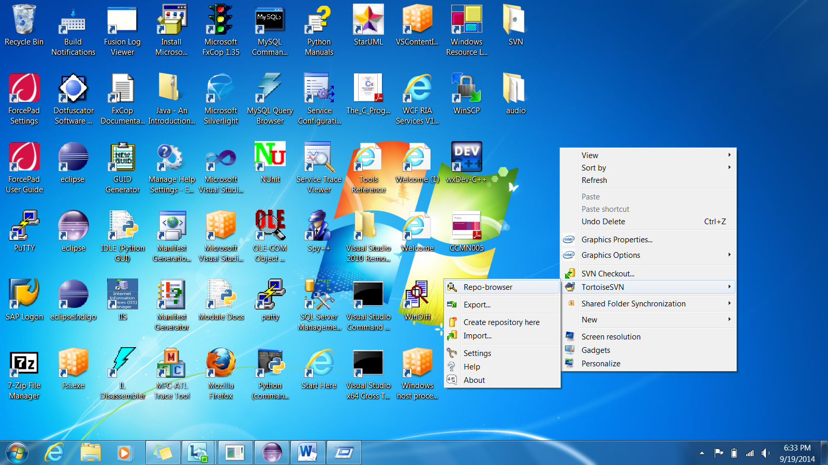

**Got to Tortoise SVN and Repo Browser and copy the url of the project in which u are in**

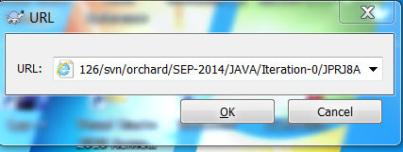 **Please note the URL which is specified   
makes sure it is https not http**

1. **Open SQL Server Management Studio and connect to the Database Server**

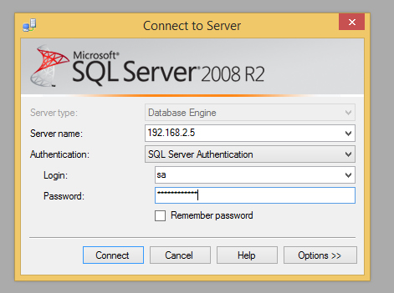

1. **Run the DB Script located under “DB Script” folder.**

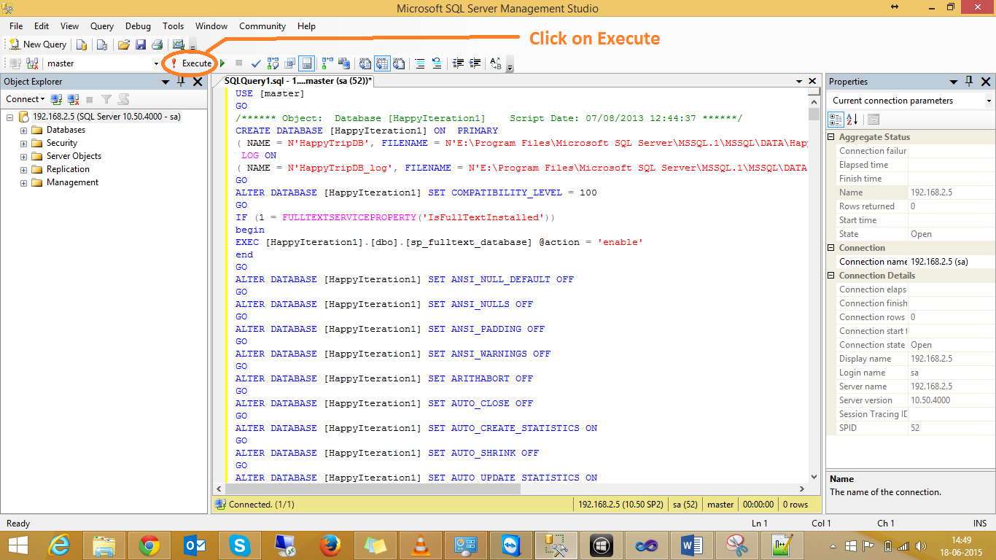

1. **Go to the folder where you checked out the code, open “Code” folder.**
2. **Open “HappyTrip.sln” with Visual Studio.**

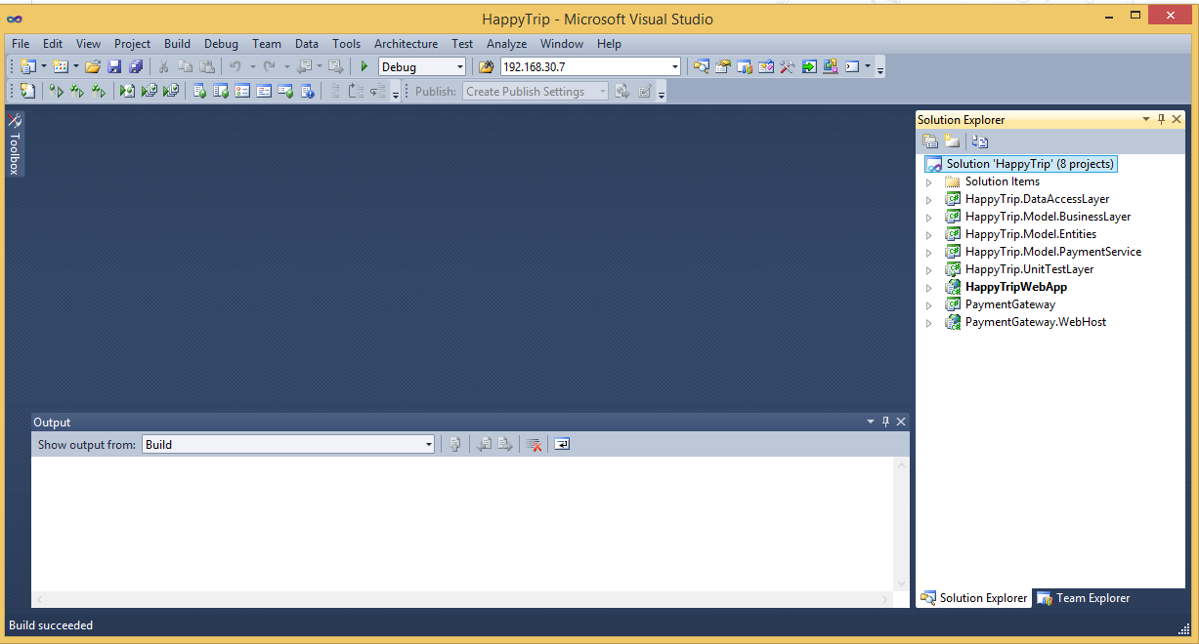

1. **Open “Web.config” under “HappyTripWebApp”.**

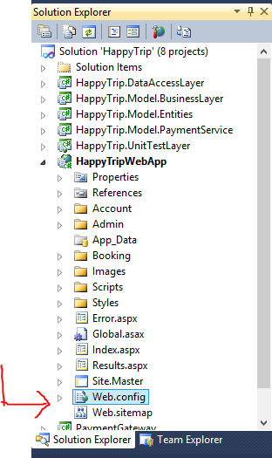

1. **Change the Connection String as per your Database server.**

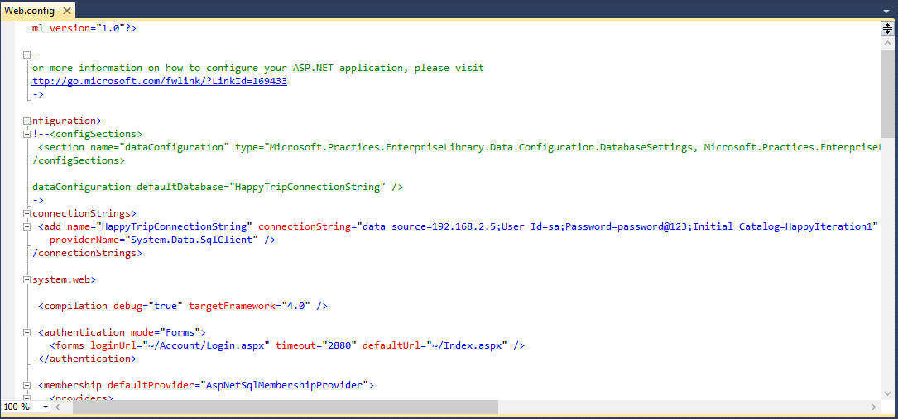

1. **Click on solution and press “Ctrl+f5”. Your project is up and running.**

